FIRE EVACUATION PROCEDURE
Please ensure that you are familiar with the evacuation routes, the location of the fire exits and the red fire alarm points (break glass/ manual call point).
If your event is in the Great Hall, you should nominate stewards who must be trained in the Maltings evacuation procedure by a member of Maltings staff, prior to the event. Without the correct number of stewards, your event will not be able to take place.
Two stewards are required for the first 100 members of the public and 1 per 100 thereafter.
- The fire alarm is a continuous siren.

- If the fire alarm sounds, evacuate the building via your nearest safe exit immediately. Do not hesitate or wait to be told to evacuate, proceed quickly via the correct route (see below), closing all doors behind you and assemble at the signed muster point at the rear of the car park.

- If you see, hear or smell smoke or fire, activate the alarm via the nearest red break glass point / manual call point (located at all exits) and proceed as above.

- Lifts may not be used during an evacuation procedure.

- Visitors or group members with limited mobility or who require additional assistance, should notify a member of the Maltings staff at the Box Office on arrival (or via the intercom or call to the Duty Team mobile number: 07717 124381)

- Those who require assistance to evacuate, should remain where they are with a chaperone. You should ensure a member of Maltings staff (in Hi-Vis clothing) is made aware of your location. If you are in immediate danger, staff will begin evacuation using in-house Evac Chairs.

- Please notify a member of Maltings staff, wearing Hi-Vis clothing, if someone in your group is not accounted for.

- Do not re-enter the building until instructed by the Maltings Fire Officer. Stand holders will be allowed to return to their stands before the general public re-enters the building.

- Do not remove fire extinguishers or use them to wedge open doors. Fire doors are integral to preventing the spread of a fire.

- Maltings staff are empowered to order the removal of any item used by visitors which may be considered a hazard.

- The Maltings is equipped with smoke detector sensors. Under no circumstances must “disco-type” smoke or vapour making machines be used anywhere within the building unless by prior arrangement with the Venue Coordinator.

Main evacuation routes
Great Hall via courtyard then RIGHT into Red Lion Lane to the Maltings car park.
Courtyard turn RIGHT into Red Lion Lane to the Maltings car park.
Stage via the exit behind the stage, via the Courtyard into the main car park.
Cellar Bar via the front patio into the main car park or via the Courtyard into the main car park.
Foyer, main toilets via the Maltings main entrance to the car park.
Riverside Café via black wooden door into the car park.
Long Kiln Gallery down the concrete staircase, across foyer to the main entrance.
Barley Room downstairs to the main entrance.
Tindle Studio, Tannery down the front metal external staircase to the main car park.
Dance Studios 1 & 2, Resident Studios, East Wing Gallery, down the metal stairs into Courtyard, then RIGHT into Red Lion Lane to main car park.
East Wing Workshop, Meeting Rooms 1 & 2 into the Courtyard, then RIGHT into Red Lion Lane to the main car park.
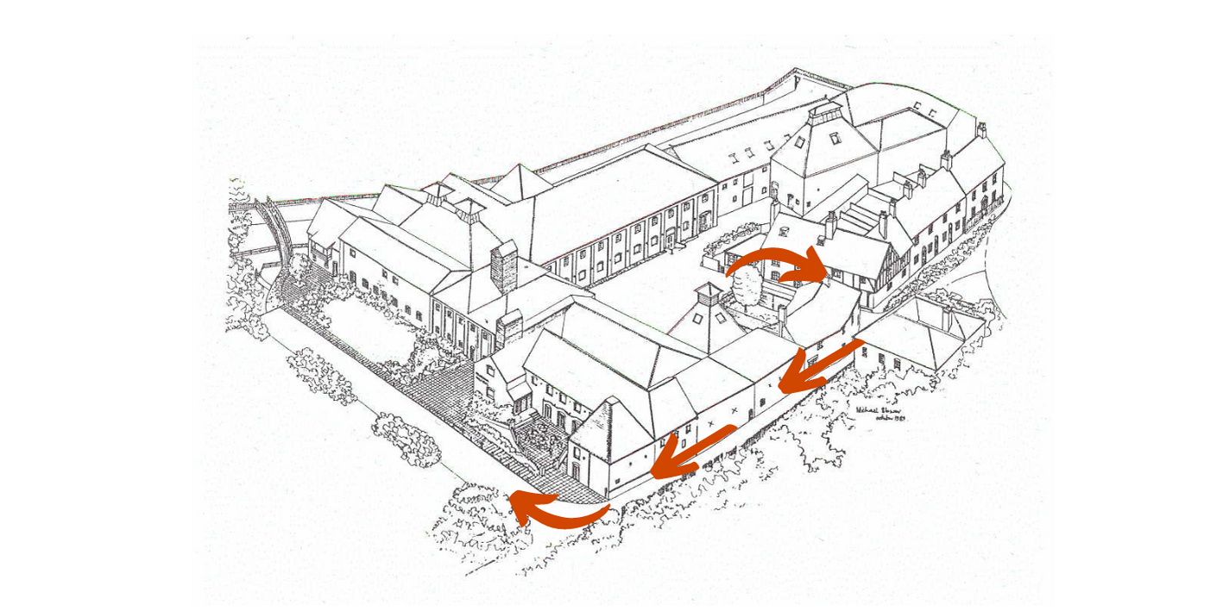
Courtyard Kiln & Southwest Kiln down the front metal external staircase to the main car park.
If main routes are blocked or too crowded, please use alternative routes.

Please sign below to confirm you understand Farnham Maltings evacuation procedures
and that you will circulate this information to people within your group.
Signature……………………………………………………………………………
Position……………………………………………………………………………..
Date………………………………………………………………………………….
Return one copy to us with your contract and keep the other for your records.
If you require further information about any of our instructions and procedures, please let us know.

